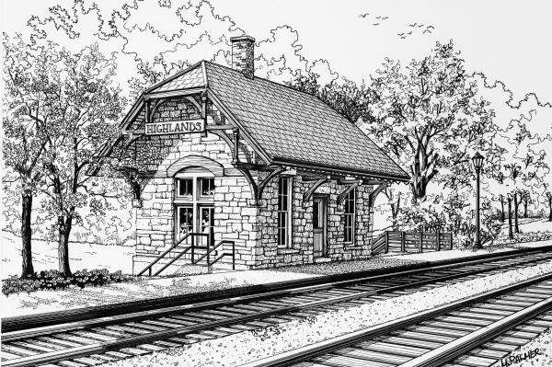
The Railroad Station Historical Society was formed in 1967 to encourage the photographing and collecting of data "on railroad stations, freight houses, signal towers, round houses, coaling towers, and other railroad buildings, to publish a bulletin entitled: Bulletin, Railroad Station Historical Society and other publications as the need arises, to act as a common meeting ground for those persons who are interested in railroad stations and other railroad buildings, and to establish archives for photographs and data on railroad stations and other railroad buildings." Information: http://rrshs.org

Membership in the Railroad Station Historical Society runs from January 1 to December 31. Members receive six issues of The Bulletin.

Membership for 2019 is available at the low cost of $15.00 (for bulk-rate mailing, U.S. address only, of The Bulletin.)

Complete the application, and mail it with your dues payable to “Railroad Station Historical Society" to:
The Railroad Station Historical Society
6 Thackeray Road
Oakland, NJ 07436-3312

Name: _____________________________________________

Address: _____________________________________________

_____________________________________________

City, State, Zip: _____________________________________________

Email: _____________________________________________

