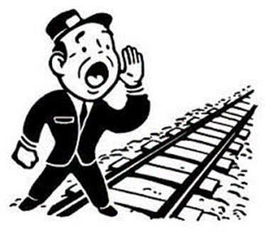
Railroad & Shortlines All Aboard!
Club of Chicago
Program on Friday, April 19th at 7:30 PM
Chicago Union Station
(Use Entrance at 500 W Jackson Blvd -- Room 107A)
Admission: Free
Over 100 Historic Photos
The Early Development of the Steam Locomotive and the American Standard 4-4-0, and
Building the Transcontinental Railroad on the
150th Anniversary of the Golden Spike (May 10th, 1869)
Program includes photos of railroad stations along the route,
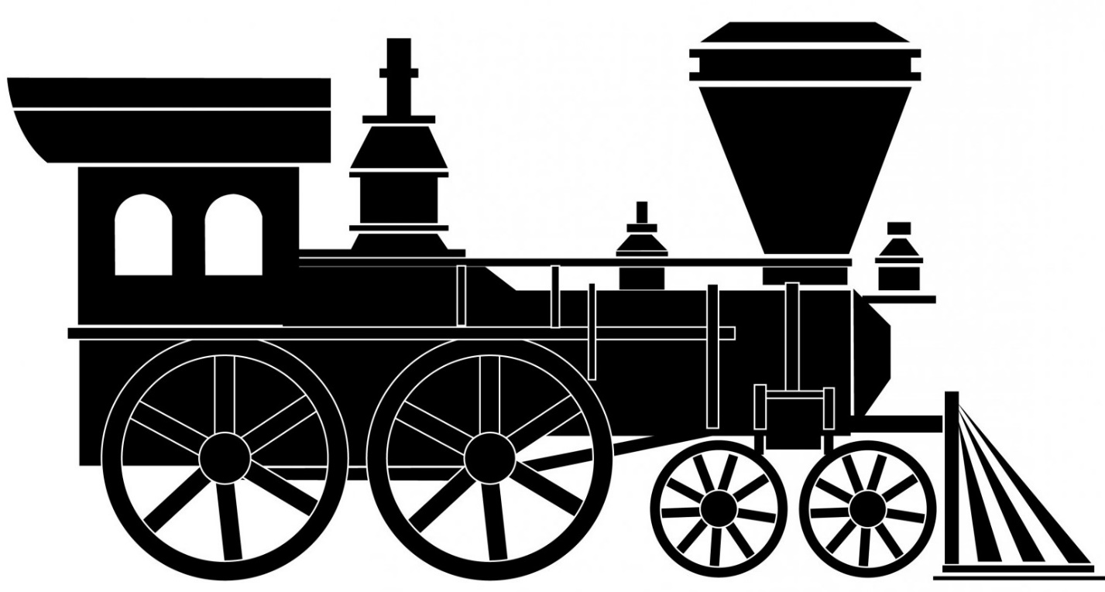
by Charles Paidock

www.RailCC.org

